Social Studies Lesson Plan Template
Fall 2013

Overview:
Lesson Title: Territorial Expansion

TSWBAT:
The student will be able to identify and explain the major instances of territorial expansion (The Louisiana Purchase, The Annexation of Texas and the Mexican Cession)

Objectives
North Carolina SCOS and 21st century skills:
“Objective 2.01: Analyze the effects of territorial expansion and the admission of new states to the Union 1801 to 1850.”
Global Awareness Skills: “Understanding other nations and cultures, including the use of non-English
Languages” (Look at British, French and Mexican influences on territorial expansion)

Materials:
Computer and Projector
White Board
Map of North America
Photocopier and Copies of US Maps
Student Vocabulary Lists
Class set of Remote Clickers

Advance Organizer

When students enter my class, they will…
Have 5 minutes to find their seat, turn in previous assignments and answer the essential question on the board. Todays EQ is: What might have spurred Americans to expand westward during the 19th Century? This topic will then be discussed briefly as a class, however the bulk of the discussion on this material will take place in a later activity. (Total time spent: 10 Minutes)
At the beginning of each Unit I would also like to pass out a vocabulary sheet with key terms on it to be completed throughout the Unit and turned in on the day of the final assessment. This will be handed out during this time.

Instructional Activities

Time | Activity
25 Minutes | Lecture  I begin by on manifest destiny and the major territorial expansions that took place between 1800 and 1850, with the Louisiana Purchase, the Annexation of Texas, 54’ 40 or Fight, the Mexican Cession and the Gadsden Purchase being the primary focus. For each expansion I will discuss the reasons for the expansion and the key players involved. During the Lecture students will be expected to take notes on key themes, and ideas and causes. These key ideas and terms will be present on their vocabulary sheet which they should use during class so that they know what information is particularly relevant and they can take notes on it in an orderly fashion on the sheet. As I lecture I will be sure to emphasize the terms on their vocab lists by repeating the pertinent information as well as writing key concepts on the board.  Take Notes
15 Minutes | Map Exercise  Students will all receive a blank copy of a map of the United States with the territorial borders from 1800 clearly marked. Students will then be broken into small groups of approximately 3s. Students will be broken up into groups by drawing from a deck of cards. This way the groups remain random and students have an opportunity to work with many different people over the course of the semester. They will then be asked to fill in the rest of the continental United States, indicating the region and year of each expansion on the map. Additionally students will be asked to indicate key locations that relate to expansion. For example, students might be asked to indicate roughly the location of the Oregon Trail and The Alamo. All of the required regions to be indicated on the map will be clearly presented in the lecture, with a number of them being key terms on the students vocabulary list. These assignments will be turned in and corrected and then returned to the students for use as a reference for the rest of the Unit.  Read Maps, Charts and Tables  Sequence Information  Create A Map
25 Minutes  (15 To Plan and  10 To Present) | Frontier Assignment  Students will then combine their 3 person groups into larger 6 person groups. Each group of six will be designated a different expansion area that they are to settle in as a group. They will have to designate individuals for leadership roles, determine what supplies they will need from the journey and for their new settlement once they arrive. Additionally they will have to come up with a viable form of livelihood once they arrive at their location. Each group will then have to give a short informal presentation (2-4 minutes).  Engage in a Simulation  Present  View Presentation (Other Students Presentations)
10 Minutes | Guided Discussion  As a class we will then talk about the advantages and disadvantages of spreading westward. I will ask questions that challenge the students to consider social, political and economic examples, while also attempting to foreshadow tomorrows lesson on the effects of territorial expansion. These questions are written below and would be put on the board at the end of class to give students an opportunity to read over them and contemplate them. Students would be encouraged to participate but not forced to contribute as long as they are paying attention. Alongside the discussion I would have the students log into TodaysMeet so that they could anonymously post ideas or questions that they may have that they are not comfortable sharing allowed to the class.  Discuss  Debate  Answer Questions

Ending of class (How will you conclude class?)

When class ends, students will…
be able to adequately identify the major territorial expansions as well as have a basic understanding of the social and political reasons for westward expansion.

Assessment (How will you know students achieved the objectives?)

Students will be assessed…
Students will be expected to complete a short 3-5 question quiz before they are allowed to leave class. This quiz will be taken using the class set of remote clickers. (Total Time: 5 minutes)
Answer Questions
Take a Quiz/Test

Transition (How will this relate to the next day’s lesson?)

This relates to tomorrow…
All of the causes and reasons for expansion, as well as the hardships experienced by frontier settlers will set the stage for tomorrows lesson on the effects of expansion.

Class Lecture: Rely Heavily on Cassrooom Maps to help Students Visualize Territories

Topics to Discuss:
- Manifest Destiny
  - The Idea that America was destined to span from the east coast all the way to the west coast.
- Louisiana Purchase by Thomas Jefferson from Napolean and the French (1803)
  - This was out of character for Jefferson b/c of his Democratic Republican political views on how the constitution should be interpreted.
  - Napolean needed the money to fund his wars in Europe
  - Buying Louisiana would remove the French Military presence from the area reducing the likelyhood of Napolean invading or promoting a slave uprising in the South.
  - People to Know
    - Jefferson
    - Napolean
    - Monroe
- Adams-Onis Treaty (1819)
  - Purchase of Florida from Spain
  - People to Know
    - John Quincy Adams
- The Annexation of Texas (1845)
  - The Alamo
    - Davey Crockett
  - Texas Independance
  - Annexation through Joint Resolution
  - People to Know
    - Martin Van Buren
    - James Polk
- 54’40 or Fight and the Oregon Dispute (1844-1846)
  - Dispute with Great Britain over where the Northern Border of Oregon would be
  - Desire to avoid another war with the British
  - Oregon Treaty and the 49th Parallel
- The Mexican Cession (1848)
  - Mexican American War or Polks War (1847)
  - Treaty of Guadalupe Hidalgo
    - Nicholas Trist
  - Ideas of Total Mexican Annexation by John C Calhoun
  - Controversy over who started the War
    - Did Polk Manipulate the US into a war by getting soldiers fired upon?
- The Gadsden Purchase (1853)
  - Area in Southern Arizona Purchased to build a transcontinental Railroad in the South.
  - Treaty was Signed by James Gadsden thus its name
Vocabulary/Key Terms List: To Be Completed during the Units Lectures and turned in on the day of the Unit Test. This will give students a guide as to what to take notes on during lectures, force students to studey for the test by completing the chart and serve as a study guid for what concepts to expect to see on the test.

Lewis and Clark
Missouri Compromise
The Indian Removal Act (1830)
Sequoyah
Worcester v. Georgia (1832)
Trail of Tears
Stephen Austin
The Alamo
Webster-Ashburton Treaty (1842)
Oregon Trail
“54 or 40’ or Fight!”
Election of 1844
Texas Annexation
Wilmot Proviso
Mexican War
Treaty of Guadalupe-Hidalgo
Mexican Cession
49ers
Gadsden Purchase
Noah Webster Neoclassical
Architecture New Nationalists/Knickerbocker School
Washington Irving
Nathaniel Hawthorne
James Fenimore Cooper
Ralph Waldo Emerson
Henry David Thoreau
Edgar Allan Poe
Alexis de Tocqueville
Hudson River School
Industrial Revolution
Eli Whitney
Cotton gin
John Deere
Steel plow
Cyrus McCormick
Samuel Morse
Robert Fulton
Erie Canal
King Cotton
Sewing machine
Dorothea Dix
Rehabilitation
Prison Reform
Horace Mann
Temperance Movement
Women’s Rights
Elizabeth Cady Stanton
Lucretia Mott
Seneca Falls Convention
Sojourner Truth
Susan B. Anthony
Utopian Communities
Brook Farm
Oneida
New Harmony
Mormons
Joseph Smith
Brigham Young
2nd Great Awakening
“Necessary evil”
William Lloyd Garrison
Grimké Sisters
David Walker
Frederick Douglass
Charles G. Finney
Map Exercise: Students will be given this blank map. They will then be asked to distinguish the regions that made up each of the major expansions starting with the Louisiana Purchase and finishing with the Gadsden Purchase. Maps will not be graded on artistic ability and perfect accuracy is in no way expected. However students should try to make their regions look relatively similar to the completed map below, with each region labeled. Additionally they will not be required to memorize the year of each acquisition but I would encourage them to put the year under the name of each region to help them remember the order in which each region was admitted to the union.

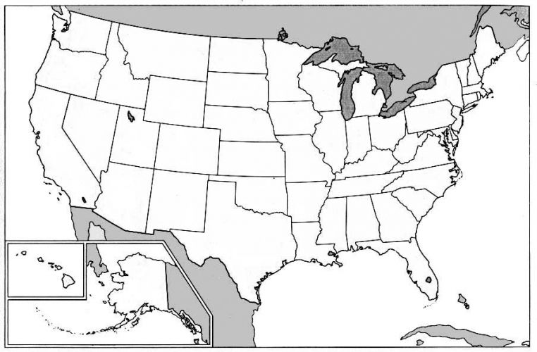

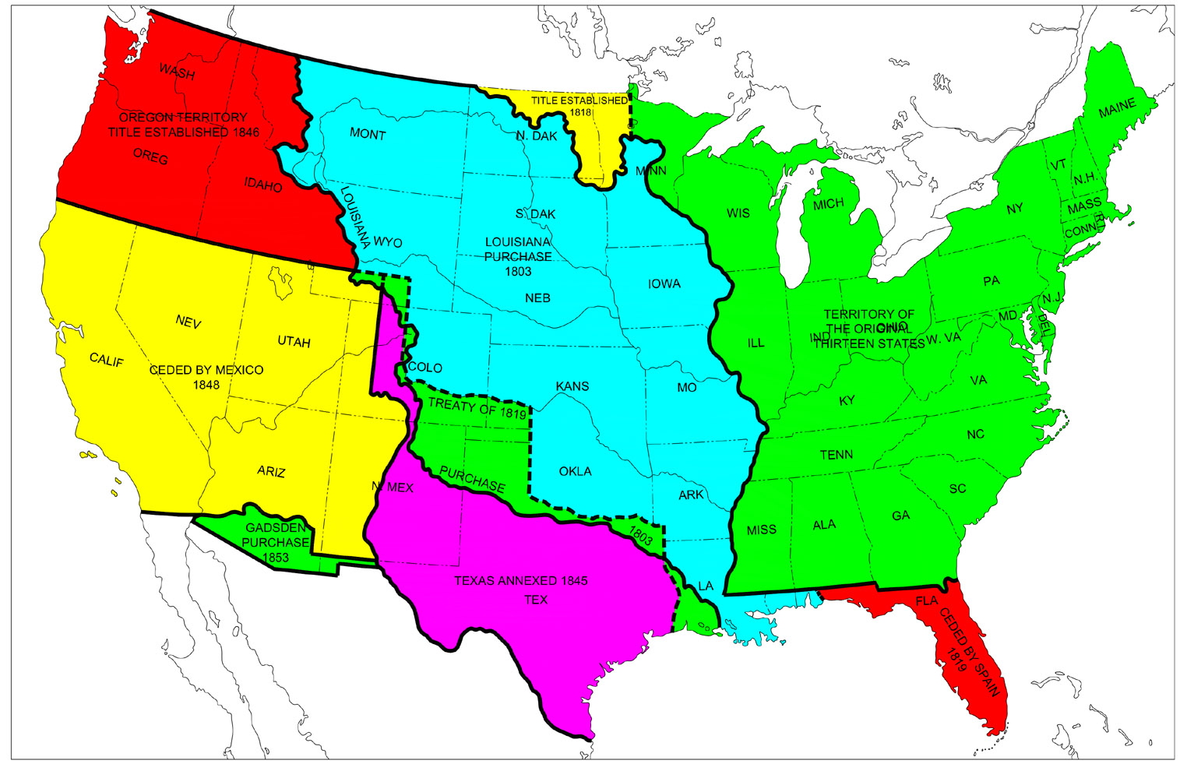
Frontier Assignment:

Within your group select two students to be leaders. One student will be the head of the group, while the other will be in charge of supplies. As a group you will then decide where you are from and what part of the frontier you would like to settle upon. You will then have to decide what supplies you will need to bring for the journey, how you plan on bringing them and what supplies you will then need to settle and maintain a sustainable homestead. Consider what professions would be most reasonable for the region you wish to migrate to. For example if you plan on going to California you could become miners or if you went to the great planes of Oklahoma you could become farmers. As a group you will then present your travel plans and supply list. Remember to think about the necessities, the frontier settlers had to pack light for these long journeys.

Guided Discussion Questions:

How do you think westward expansion affected the Native Americans already settled in these territories?

How do you think the North would have felt about Territorial expansion? The South?

What potential conflicts or problems do you see arising from territorial expansion on a national level? On Regional Levels?

